**Motherboard**

Motherboard or Printed Circuit Board (PCB) is the element of the PC that combines all the hardware to work together. It always has a CPU socket (for the different generations & companies producing CPUs there usually are different sockets), also RAM slots are mandatory, slots to power the motherboards itself, the CPU and all other components. There also are SATA ports to connect the storage for your computer. There are 2 types of PCI slots – PCI-E (Express) and PCI. PCI-E slots are usually used for graphic cards, because they can process more bandwidth in a shorter amount of time. On the PCI slots people usually attach after-market LAN cards or Sounds cards etc. There is also the M.2 PCIe slot which serves as a smaller PCI-E. People usually use them to attach the fastest possible SSDs there. On the motherboard are positioned all the pins that are used to connect the front end of the PC case. For example the Power button, Reset button and all these functions like Hard-Drive LED, Power on LED etc. Usually, whenever people build PCs for the first time they have the most issues with connecting these pins the right way, because there are not much instructions and your workspace is very tight and small (Since the PCB is already in the case, screwed). There are many more ports on the motherboard such as USB ports, fan for the CPU cooler, fans for the case and every different motherboard model has different features. This is one of the reasons why you have to consult with a person who understands the pros and cons whenever you are buying a motherboard.

Here is a picture of a motherboard with the same chipset but I cannot confirm this is the exact model they use in this PC configuration since they don’t specify it on the website. 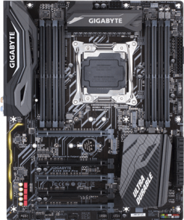

In this exact build the motherboard has these features:

* Intel 2066 Socket
* X299 express chipset
* 8xDDR4 DIMM sockets for RAM (max capacity – 128 GB), when using a 6 core or above CPU
* 4xDDR4 DIMM sockets for RAM (max capacity – 64 GB), when using a 4 core or above CPU
* Dual or 4 channel memory architecture respectively
* Ram speed support – between 2133 MHz and 4400 MHz
* 5x PCI-E 3.0 slots
* 2x M.2 Connectors
* Intel Optane ready (this is special kind of memory that Intel developed that makes your HDD faster)
* 2x USB 3.1 Gen 2 ports
* 10x USB 3.1 Gen 1 ports
* 4x USB 2.0 Gen 1.1 ports
* ATX Form Factor

**CPU Cooler**

The CPU cooler is a very important part of every PC and is mandatory for the computer to work. It’s function is to cool down the processor of the PC so it continues its work properly. Usually, the bigger the cooler the better, but you should always have in mind the type of processor you have so you can buy a corresponding cooler. CPU socket also matters !!! Always check if your CPU cooler can be mounted on the socket you have and ALSO if it will fit into the PC case. There are AIO (All-In-One) CPU coolers, that use air to cool the heatsink (and more specifically, fans blowing air into the heatsink), and then there are the water CPU coolers, which use the heat charge & discharge properties of the water to cool the PC way faster and more efficient. It works by making a closed circuit with tubing, a pump, radiator (where the water discharges the heat it has absorbed) and a water block (this is attached on top of the processor instead of a heatsink to absorb the high temperature). This kind of cooling is very customizable and you can do whatever you want to with it. For example, since you distilled water in the circuit, you can put colouring agents in it, to make it cooler-looking. Or people sometimes make custom water loops that are cooling both their CPU and GPU(s).

For this particular build CPU cooler is said to be a liquid cooling circuit integrated into the case itself. I will give an example with another PC how a water cooling circuit might look like:

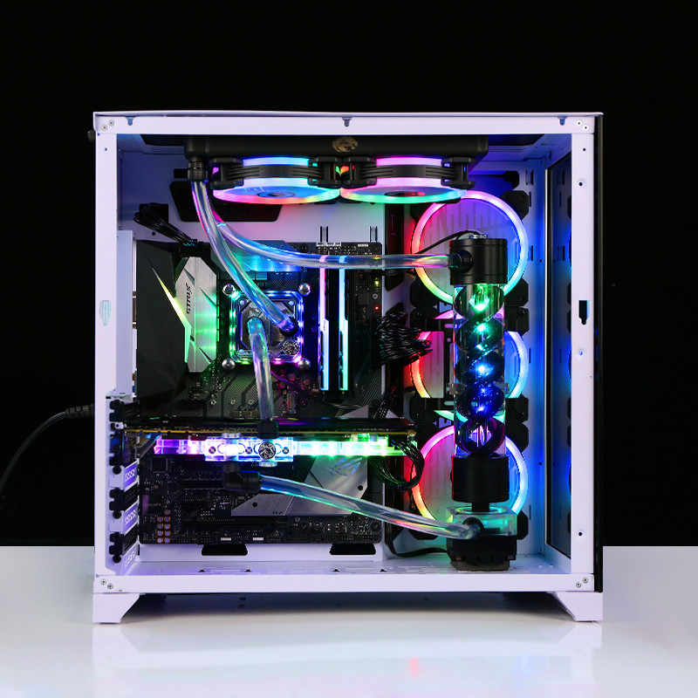

**CPU**

The CPU is the brain of the computer. Every system that does some kind of calculations has a CPU. Modern CPUs are extremely powerful compared to older ones. This is because the way they are built is constantly evolving. For example 10 years ago the processors were built with a 32 nanometre technology, which limited their power in certain ways (Even though they were still powerful enough for the tasks assigned to them at the time). Nowadays most of the processors are built with the 7nm technology since they can pack more power and more semi-conductors into the same chip size. In the near future I believe the 5 nm technology will be implemented which means processors are going to get even more powerful. While working processors get very hot up to 100 degrees Celsius (and that temperature they usually shut down themselves for safety reasons). Processor’s computing power is measured in Hz or usually GHz (to use smaller numbers in indicating its speed). CPUs always have cores. Modern processors usually have 4 or more “physical” cores, the thing is, that cores help the processors do things simultaneously. Why is that ? Because as we know they do everything in order, one-by-one, so if we put more tasks on it then it is going to throttle and here is where the different cores come in handy. They usually decrease the speed of the processor by a certain amount, but let it operate on a few things at once. There are “virtual” cores as well and this is basically simulated cores, operating as physical ones. CPUs have cache memory which serves as a mediator between CPU’s logical sector and RAM. The bigger the cache memory the better ! Always a rule !

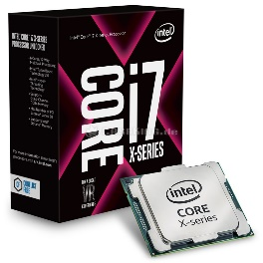

The specs of the CPU featured in this build:

CPU model: Intel Core i7 7800X – 64 bit, 7th generation “Skylake” processor, LGA INTEL 2066

Technology used (Lithography): 14nm

Physical Cores: 6

Base Frequency: 3.5 GHz

Max Turbo Frequency: 4 GHz (This is activated once the processor needs more processing power but doesn’t stay on all the time to save power & not to produce too much heat)

Cache memory capacity: 8.25 MB

TDP (Thermal Design Power): 140 Watts

Max supported memory capacity: 128 GB

Memory type supported: DDR4 2400 MHz up to 4000 MHz – Quad-Channel memory

GPU

The GPU (also known as Graphic Processing Unit) is the piece of hardware that usually renders the image on the monitor. It is really similar in build to the CPU but differs in one specific thing – it mostly executes parallel processes unlike the CPU which executes consequential processes. The GPU can do many things at once, unlike the CPU which does everything one after another. The GPU is really good at image processing but extremely bad and slow in logical operations. It’s the opposite for the CPU. There is one specific thing you need to be careful with, and that is if your power supply will be sufficient for the graphics card of your choice. Since CPUs and other component usually don’t need too much power, you should always pay attention to the wattage rating of your power supply and whether or not it has the capacity to take the TDP of your graphics unit. The GPU is usually the hardware component that most PC geeks talk about. Since it’s not a mandatory part for the PC to work, not every computer has a designated graphics unit. Some CPUs offer an “integrated GPU” which is basically using the CPU as a graphics processing unit. This method can be used for lighter application but won’t be able to run games smoothly at high resolutions and settings. For the featured build the computer has an 1080TI, which was released in the beginning of 2017. By the time it was advertised as the most powerful video card on the market, after TITAN X and TITAN XP (All of these graphic card models are owned by Nvidia). The 1080TI is able to run pretty much any game at it’s highest settings even at higher resolutions (1440p, 2160p). It is still extremely powerful to this day but right now there are cheaper, newer cards on the market featuring the same performance.

Specs of 1080 TI:

* Nvidia Founders Edition
* CUDA Cores – 3584 (The more the faster operations can be executed)
* Boost Clock (Max clock speed) – 1582
* Memory capacity – 11GB
* Memory type – GDDR5X
* Memory speed – 11Gb/sec
* Memory Bandwith – 484 GB/sec
* Connection type (To MB) – PCI-E 3rd generation
* Maximum digital resolution – 7680x4320 @ 60 Hz/sec
* Connectors – 1xDisplay port 1.4, 1xHDMI 2.0B
* Graphics card TDP – 250 Watts
* Connection from Power Supply – 1x 6-pin connector, 1x 8-pin connector

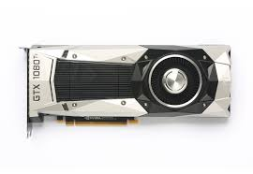

The computer we are using for this report is:

Alienware Area-51 R4

<https://www.cnet.com/products/alienware-area-51-r4-tower-core-i7-7800x-x-series-3-5-ghz-16-gb-2-256-tb/>

GPU info - <https://www.nvidia.com/en-us/geforce/products/10series/geforce-gtx-1080-ti/>

Motherboard info - <https://www.gigabyte.com/Motherboard/X299-UD4-Pro-rev-10/sp#sp>

<https://azerty.nl/product/gigabyte/3128017/x299-ud4-pro-rev-1-0-moederbord-atx?gclid=Cj0KCQjwoKzsBRC5ARIsAITcwXFF-ODFUGkrXvCMW2ltH7k5pGmuJcZ7_5P9C7yHDtyho6iMhWQIHN0aAk7vEALw_wcB>

CPU Info –

<https://ark.intel.com/content/www/us/en/ark/products/123589/intel-core-i7-7800x-x-series-processor-8-25m-cache-up-to-4-00-ghz.html>

<https://cpu.userbenchmark.com/Compare/Intel-Core-i9-7900X-vs-Intel-Core-i7-7800X/3936vsm304816>

Pros and Cons:  
Pros – Extremely powerful, no software will be able to make this machine lag or stutter.

Cons – Very expensive, not quite customizable since it’s a pre-built PC, might be loud under load because of Fans trying to dissipate most of the heat, heave, case shape is not appealing to me and it seems impractical.